- Write a C program to perform matrix addition for 3*3 matrix.
#include<stdio.h>
int main()
{
int i,j,a[5][5],b[5][5],c[5][5];
printf ("enter the elements of first matrix:\n");
for (i=0;i<3;i++){
for(j=0;j<3;j++){
scanf("%d",&a[i][j]);
}
}
printf ("enter the elements of second matrix:\n");
for (i=0;i<3;i++){
for(j=0;j<3;j++){
scanf("%d",&b[i][j]);
}
}
for (i=0;i<3;i++){
for(j=0;j<3;j++){
c[i][j]=a[i][j]+b[i][j];}}

printf ("the matrix addition of a and b is:\n");
for (i=0;i<3;i++){
for(j=0;j<3;j++){
printf("%d\t",c[i][j]);}
printf("\n");}
return 0;}
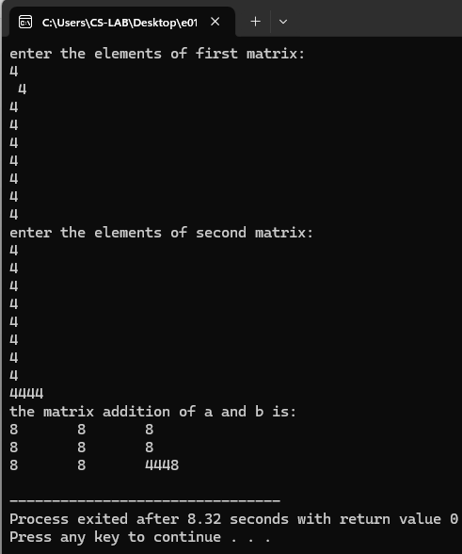
- Write a C program to perform matrix multiplication
#include<stdio.h>
int main ()
{ int r1,c1,r2,c2;
int i,j,k;
printf("enter the number of rows and column for the first matrix\n");
scanf("%d%d",&r1,&c1);
printf("enter the number of rows and column for the seconod matrix\n");
scanf("%d%d",&r2,&c2);
if (c1!=r2){
printf(" error the number of columns of first matrix should be equal to number of rows in second matrix for matrix multipication\n");
return 1;
}
int m1[r1][c1],m2[r2][c2],r[r1][c2];
printf("enter the elements of the first matrix\n");
for(i=0;i<r1;i++){
for(j=0;j<c1;j++){
scanf("%d",&m1[i][j]);
}
}
printf("enter the elements of the second matrix\n");
for(i=0;i<r2;i++){
for(j=0;j<c2;j++){
scanf("%d",&m2[i][j]);
}
}
for(i=0;i<r1;i++){
for(j=0;j<c2;j++){
r[i][j]=0;}}

for(i=0;i<r1;i++){
for(j=0;j<c2;j++){
for(k=0;k<c1;k++){
r[i][j]=r[i][j]+m1[i][j]*m2[i][j];
}
}
}
printf(" MATRIX MULTIPLICATION OF M1 AND M2 IS:\n");
for(i=0;i<r1;i++){
for(j=0;j<c2;j++){
printf("%d\t",r[i][j]);
}printf("\n");
}
return 0;
}
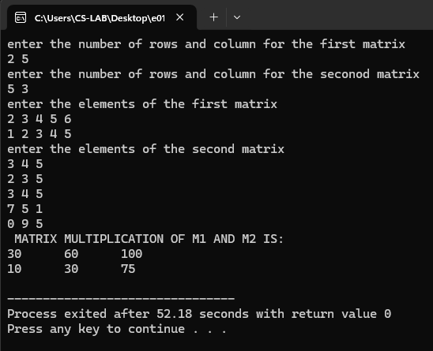
3. Write a C program to create an array to store the basic salary of 5 employees. The program should:
● Calculate the Gross Salary for each employee using the formula: Gross Salary=Basic Salary+20%DA+10%HRA
● Display the Basic Salary and Gross Salary of each employee.
● Find and display the highest and lowest Gross Salary among all employees.
#include <stdio.h>

int main() {
int n = 5;
float bs[n];
float gs[n];
float dr = 0.20;
float hr = 0.10;
int i;

printf("Enter the basic salary for 5 employees:\n");
for (i = 0; i < n; i++) {
printf("Employee %d Basic Salary: ", i + 1);
scanf("%f", &bs[i]);
}

for (i = 0; i < n; i++) {
float da = bs[i] * dr;
float hra = bs[i] * hr;
gs[i] = bs[i] + da + hra;
}

printf("\nEmployee Salary Details:\n");
printf("Employee | Basic Salary | Gross Salary\n");

for (i = 0; i < n; i++) {
printf("%8d | %12.2f | %12.2f\n", i + 1, bs[i], gs[i]);
}

float highest = gs[0];
float lowest = gs[0];

for (i = 1; i < n; i++) {
if (gs[i] > highest) {
highest = gs[i];
}
if (gs[i] < lowest) {
lowest = gs[i];
}
}

printf("\nHighest Gross Salary: %.2f\n", highest);
printf("Lowest Gross Salary: %.2f\n", lowest);

return 0;
}
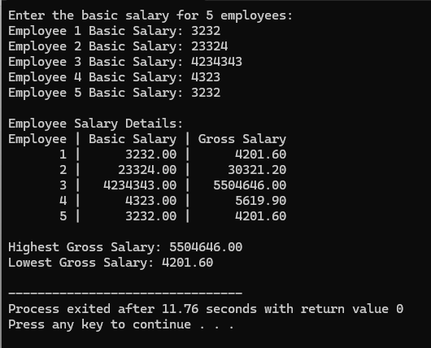
4. Write a C program to create an array to store marks of 2 students in 3 subjects each. The program should:
● Input marks of each student.
● Calculate and display the Total Marks and Average Marks of each student.
● Also find and display the Highest and Lowest mark of each student.
#include <stdio.h>

int main() {
int marks[2][3];
int i, j;

for (i = 0; i < 2; i++) {
printf("Enter marks for Student %d:\n", i + 1);
for (j = 0; j < 3; j++) {
printf(" Subject %d: ", j + 1);
scanf("%d", &marks[i][j]);
}
}

for (i = 0; i < 2; i++) {
int totalMarks = 0;
float averageMarks;
int highestMark = marks[i][0];
int lowestMark = marks[i][0];

for (j = 0; j < 3; j++) {
totalMarks += marks[i][j];
if (marks[i][j] > highestMark) {
highestMark = marks[i][j];
}
if (marks[i][j] < lowestMark) {
lowestMark = marks[i][j];
}
}

averageMarks = (float)totalMarks / 3;

printf("\nStudent %d:\n", i + 1);
printf(" Total Marks: %d\n", totalMarks);
printf(" Average Marks: %.2f\n", averageMarks);
printf(" Highest Mark: %d\n", highestMark);
printf(" Lowest Mark: %d\n", lowestMark);
}

return 0;
}
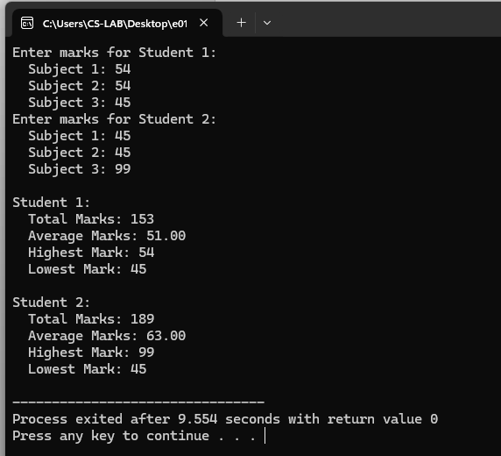
5. Write a C program to create a 2D array to store marks of 5 students in 3 subjects each. The program should:
● Input marks of all students.
● Calculate and display the Total Marks and Average Marks of each student.
● Assign a Grade to each student based on average: ○ ≥ 90 : Grade A ○ 75–89 : Grade B ○ 50–74 : Grade C ○ < 50 : Grade D
● Display each student’s Total, Average, and Grade.
#include<stdio.h>
int main ()
{int st[5][3],i,j,tm[8],am[8],grade[5];
for (i=0;i<5;i++){
printf("enter the marks of student %d\n",i+1);
for(j=0;j<3;j++){
scanf("%d",&st[i][j]);}}
for (i = 0; i < 5; i++) {
tm[i] = 0;
for (j = 0; j < 3; j++) {
tm[i] += st[i][j];
}
am[i] = (float)tm[i] / 3;

if (am[i] >= 90) {
grade[i] = 'A';
} else if (am[i] >= 75) {
grade[i] = 'B';
} else if (am[i] >= 50) {
grade[i] = 'C';
} else {
grade[i] = 'D';
}
}
for (i = 0; i < 5; i++) {
printf("Student %d:\n", i + 1);
printf(" Total Marks: %d\n",tm[i]);
printf(" Average Marks: %d\n", am[i]);
printf(" Grade: %c\n", grade[i]);
}

return 0;
}

